How to enable screenshots from a video played by MS Windows Media Player

Most of the time, you can press the Print Screen key of your keyboard and then use MS Paint to paste what have been copied to get a screenshot of your Windows desktop (use Alt+Print Screen keys if you want to only capture the current selected window). However, sometimes you only get a black area when you try to capture a frame from a video played by MS Windows Media Player. You can sometimes solve that problem by changing the overlay-related options that you can find here (unchecking use overlays worked for me…):
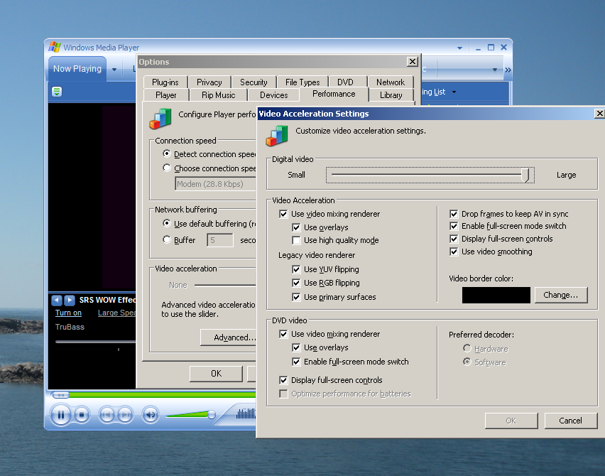
However, be sure to restore your original options when done because the default options were probably the best compromise between performance and reliability…

