How to select an area bigger than the screen in an image with MS Paint

1st method
You can use the mouse wheel to scroll vertically while you maintain the left-click button to move and select the desired area. To scroll also horizontally, use CTRL+arrow keys (this can be used also to scroll vertically instead of using the mouse wheel).

2nd method
First you can easily temporarily reduce the bottom part of the image
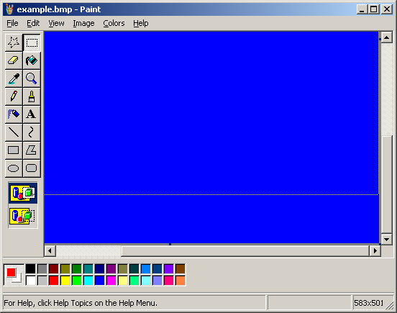

Same with the right border
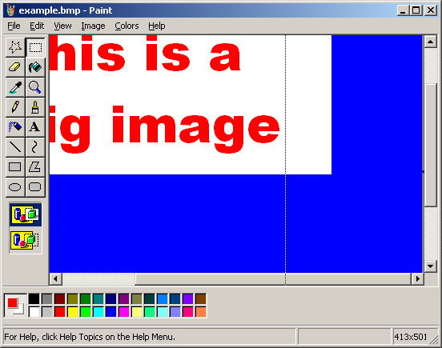

The problem is that you cannot directly do the same with the left and upper corners. The trick is to use the flip functions of Paint…
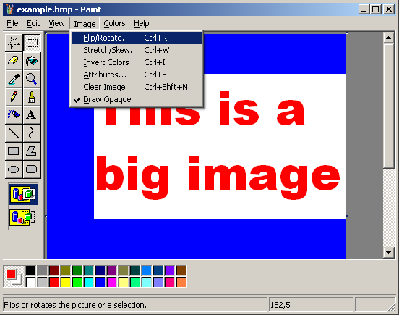
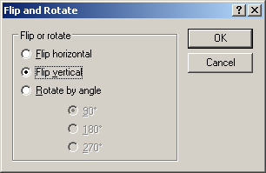

You can now do the same as before
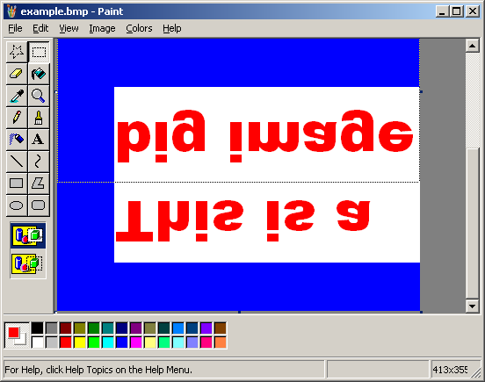

When done you flip again and use the select all function with the result
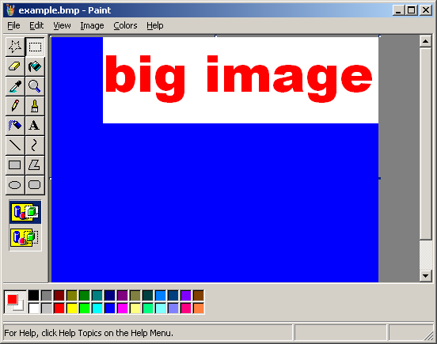

3rd method (from Jan SLIWKA)
You select the entire image with CTRL+A and then left-click on it and move the mouse to move the image to the up and left until where you want to delete the unneeded upper and left borders parts.

