C/C++ programming with Qt 5.15.1 and Visual Studio 2019

Install Visual Studio 2019 with options as described in https://www.ensta-bretagne.fr/lebars/Share/setup_vs2019_opencv420.pdf.

Download and run http://download.qt.io/official_releases/online_installers/qt-unified-windows-x86-online.exe and select Qt\Qt 5.15.1\MSVC 2019 32 bit (keep other default options unless you need other things):

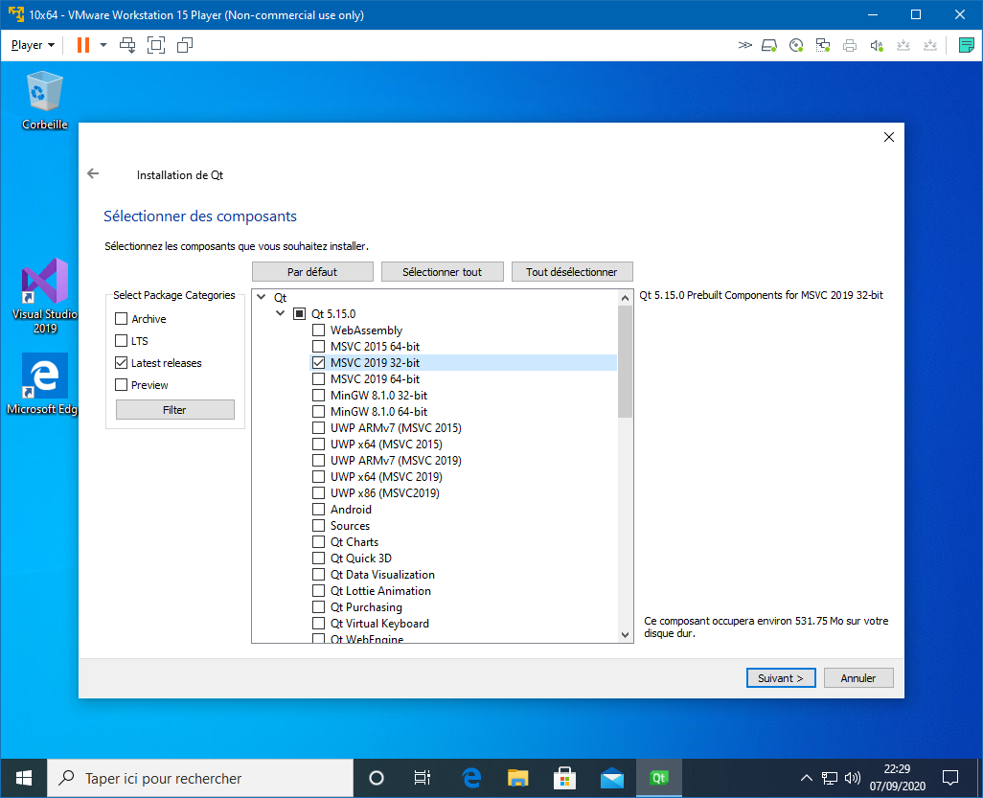

At this point you can use Qt Creator IDE to create a project, it would build it with Visual Studio 2019 compiler. But if you wish to program using Visual Studio 2019 IDE, download and install http://download.qt.io/archive/vsaddin/2.5.2/. Then, you need to indicate Visual Studio where to find Qt files:

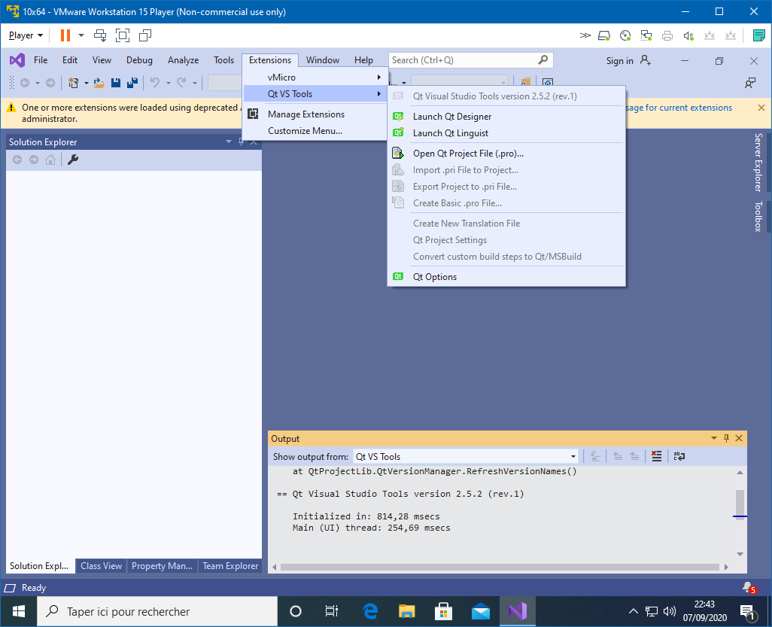
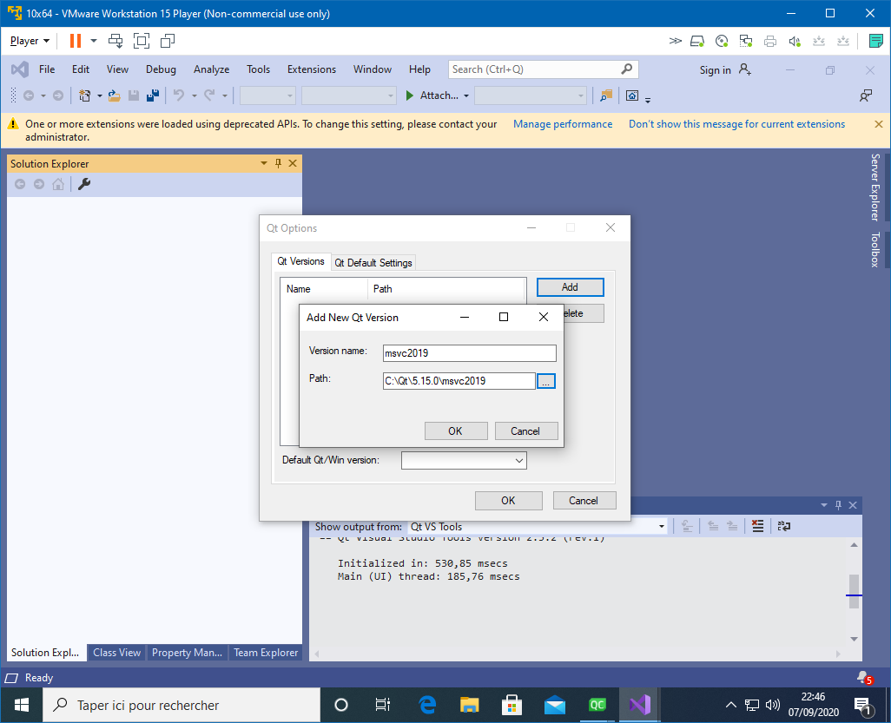

Search for “qt” to get a Qt project template :
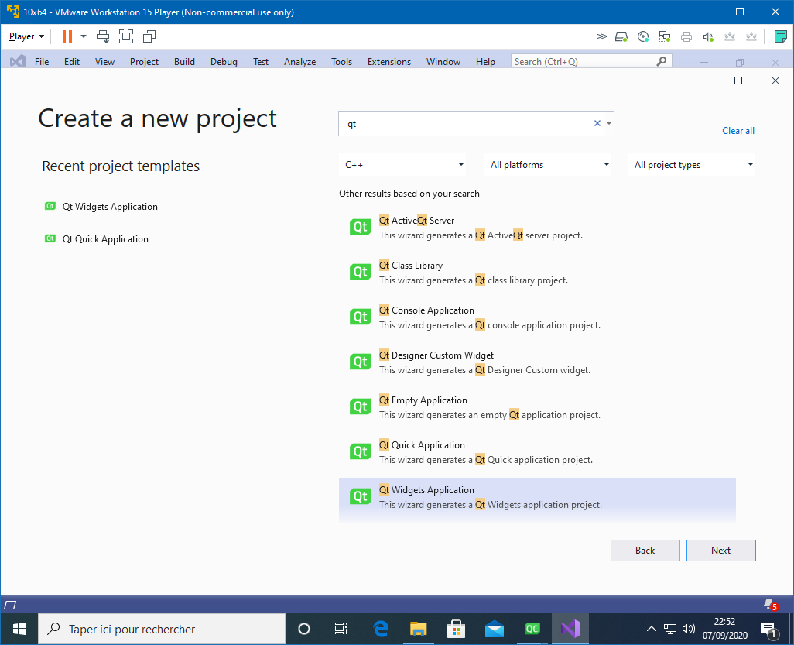

Note that you will still be able to use Qt Designer if you open the .ui file:
