The World Robotic Sailing Championship, a competition to stimulate the development of autonomous sailboats

Fabrice Le Bars and Luc Jaulin
STIC/OSM, Lab-STICC/CID/IHSEV
ENSTA Bretagne
Brest, France
{fabrice.le_bars, luc.jaulin}@ensta-bretagne.fr

Abstract—The WRSC (World Robotic Sailing Championship) / IRSC (International Robotic Sailing Conference) is an international and annual competition and conference that aims at stimulating the development of autonomous marine robotics and its applications. The competition, originally designed for sailboats, is also opened to motorboats as a separate category since 2013. In this paper, we will present the competition through the example of the 2013 edition, and show its results, specificities, issues as well as improvements for the next editions.
Keywords—autonomous robots; sailboats; WRSC; IRSC

A competition to promote autonomous marine robots, especially mini sailing robots
The need of this kind of competition has been raised by the fact that few studies on autonomous sailboat robots had been done, while their possibilities to conduct long missions at sea with few perturbations of their environment began to be foreseen (see e.g. [2], [3], [4], [5]). As one of the most challenging task while being close to what we could expect from this kind of robots, the Microtransat challenge [6] proposes to build autonomous sailboats of less than 4 m long able to cross the Atlantic Ocean. This implies to have robust hardware able to work at sea during several months, an intelligent power handling system, sensors and control algorithms robust enough to handle the varying environmental conditions, as well as a communication and logging system able to show the trajectory during the mission.
After some team meetings to share their progress in the making of such sailing robots, the need of intermediate challenges, more easy to reach than the Microtransat, was clear to help to general improvements in sailing algorithms and hardware, as well as easily show the capabilities of the robots to potential users and raise interests in autonomous sailing robots.
With those considerations in mind, the WRSC competition proposes tasks such as station, speed in different conditions, accuracy, obstacle avoidance, target tracking, endurance, cooperation, while the accompanying IRSC conference provides an ideal venue to discuss the broad range of scientific problems involved in the design and development of autonomous sailboats.

The WRSC/IRSC 2013
The WRSC/IRSC 2013 (see [1] and Fig. 1) was the 6th edition in a series with previous events held in Austria (2008), Portugal (2009), Canada (2010), Germany (2011) and the Wales/UK (2012) (see [2]). The main novelty of this competition was to propose tasks designed for other types of surface vehicles in addition to sailboats.
- WRSC/IRSC 2013.
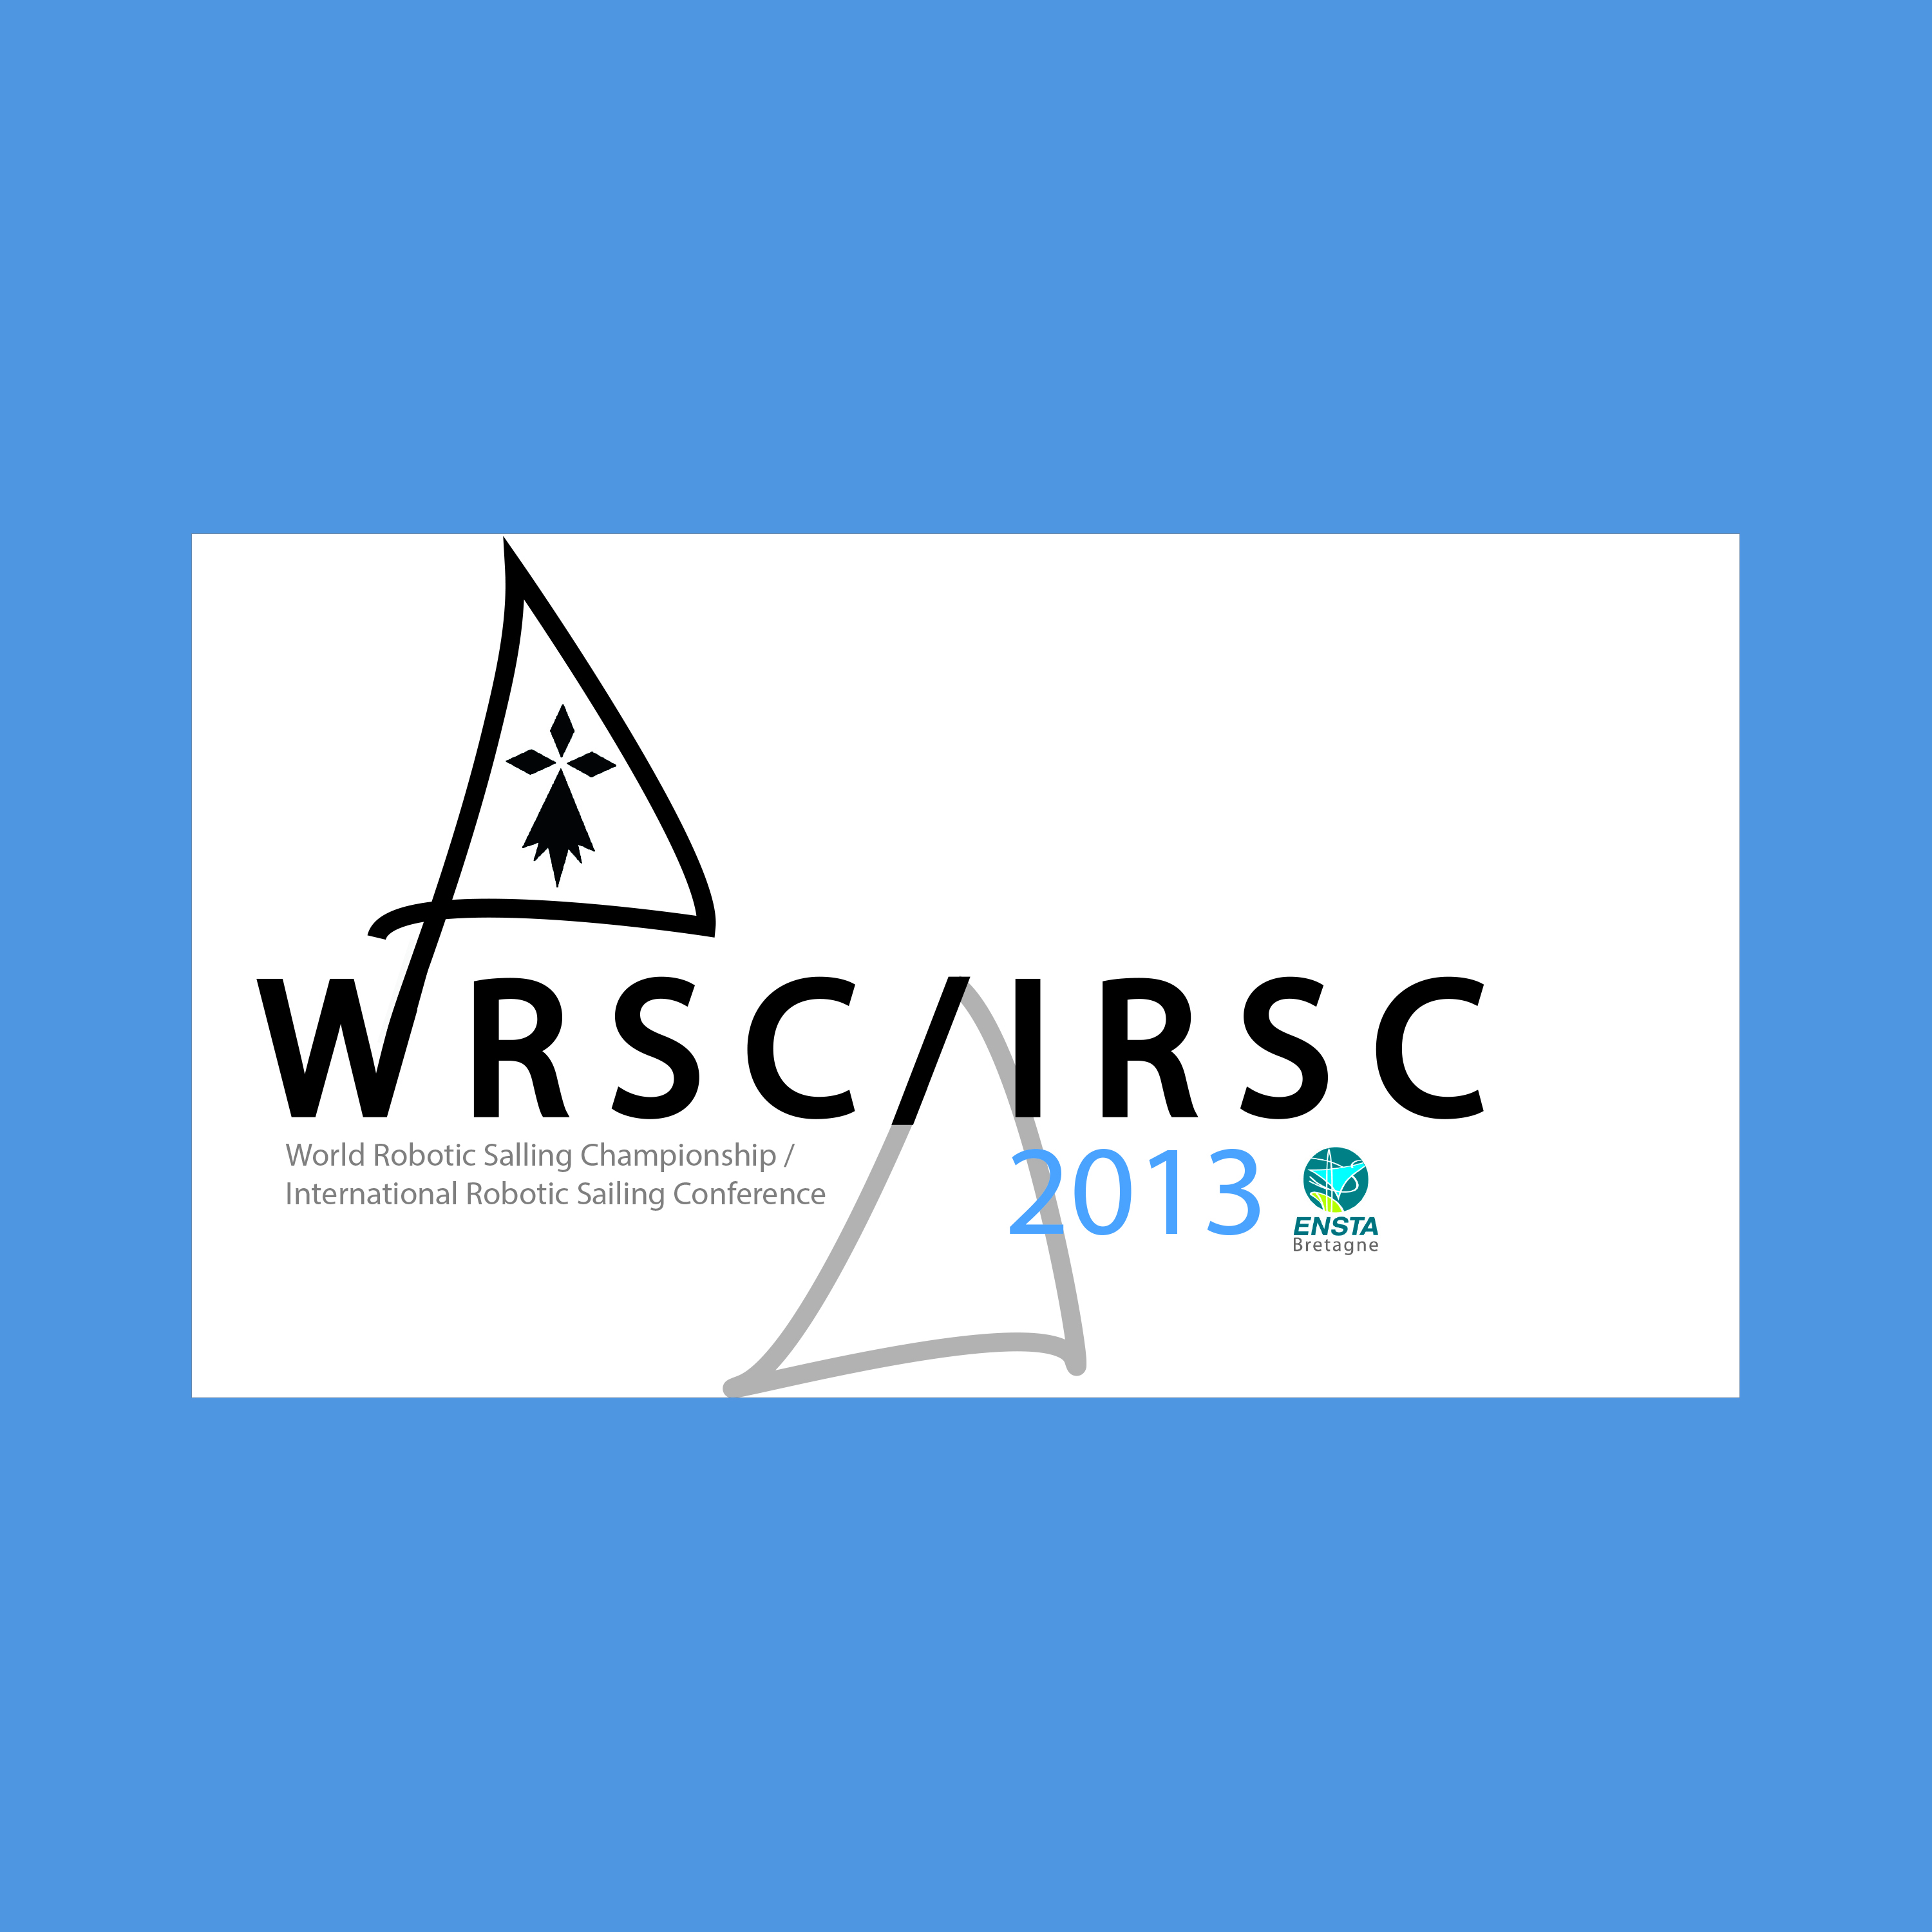
Due to its recent activities in marine robotics activities (e.g. with VAIMOS autonomous sailboat, see [8], [9]), ENSTA Bretagne was chosen during the previous edition as the best candidate to organize the WRSC/IRSC 2013. The main organizers were Fabrice LE BARS and Luc JAULIN (ENSTA Bretagne). Partners were :
- Centre nautique de Brest Moulin-Blanc
- Ifremer
- DGA/TN/GESMA
- Ecole Navale
- SRB
Contracts, sponsors and grants that made possible the event involved :
- DGA/DS/MRIS
- MBDA
- BMO
- Conseil général du Finistère
- Région Bretagne
This event was also supported by the Lab-STICC (local laboratory), GDR MACS and GDR Robotique (sort of national equivalents of European Topic Groups in Automatics and Robotics).
The WRSC/IRSC 2013 was organized from the 2nd to the 6th of September 2013 in Brest, France (see http://www.ensta-bretagne.fr/wrsc13). Until the 2013 edition, the WRSC/IRSC was exclusively reserved to sailing robots, like Sailbot, its american equivalent (see www.sailbot.org), while the Roboboat competiton of AUVSI (also an american competition, see www.auvsifoundation.org/foundation/competitions/roboboat) proposed tasks designed for motorboats, and hard to complete with sailboats. To our knowledge, it did not have another european equivalent in 2013.
The different categories of robots were the following (see rules on http://www.ensta-bretagne.fr/lebars/wrsc2013/Rules_2013-08-28.pdf):
- Small autonomous sailboats up to 1 m long, 2 m high, 100 kg, referred to Microsailboats category (MS code).
- Autonomous sailboats up to 4 m long, 10 m high, 500 kg, referred to Sailboats category (S code).
- Any type of autonomous boat up to 4 m long, 10 m high, 500 kg, referred to Motorboats category (M code).
There were 2 types of teams:
- Student teams: at least 50% of students (including PhD students as students), one of the student being the Team Leader, max of 10 people and have at least 1 robot. Their robots were ranked in the student ranking.
- Open teams: the only requirements are a max of 10 people and have at least 1 robot. Their robots were ranked in the open ranking.
Proposed tasks involved problems such as station, speed in different conditions, accuracy, obstacle avoidance, target tracking, endurance, cooperation, etc. (see Fig. 2 and [1] for more details).
- Competition area around Moulin-Blanc harbor.
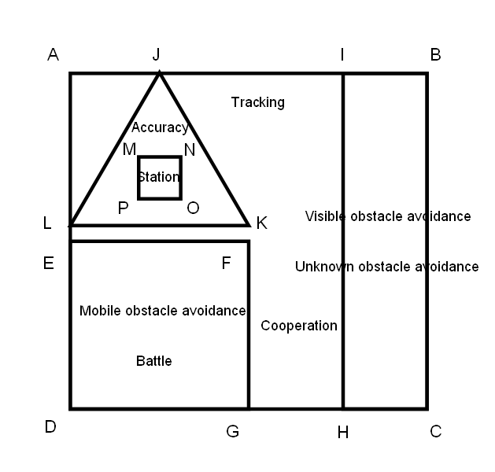
Here is a quick description of the main tasks, as well as the ideas behind them:
- Station keeping task: stay as long as possible in the middle of a square of 50 m. For example, a robot that is doing a mission at sea often needs to stay in specific areas to make measurements during a long time, or for a rendez-vous with an oceanographic boat that should recover it (see e.g. [5] and [8]).
- Accuracy task: follow a triangle trajectory as accurately as possible. One of the common drawbacks of sailboats is that they are quite sensitive to the wind direction with respect to them. However, it can be shown that using an efficient control strategy, we can guarantee that the sailboat always stay in a predefined corridor (see [9]).
- Mobile obstacle of known position avoidance task: avoid collision with a disruptive boat, knowing its position at all times. Collisions with other vehicles in the sea often happen (or need manual intervention to be avoided) during most of the tests close to the coast, but also far from land for long experiments (see [8]). As most of the boats offshore are equipped with the AIS (Automatic Identification System), it should be possible for a robot equipped with this system to adapt its trajectory to minimize the risks of collision (the AIS should give information such as position, speed, orientation, destination, type of boat, see e.g. [10]).
- Endurance task: cover autonomously a distance of 10 nm (about 20 km). The main advantage of a sailing robot over a motorboat of the same size is its ability to cover long distances and stay longer at sea thanks to its low power requirements. Therefore, this task is one of the most important to demonstrate the usefulness of autonomous sailboats.
- Robots trajectories for several tasks.
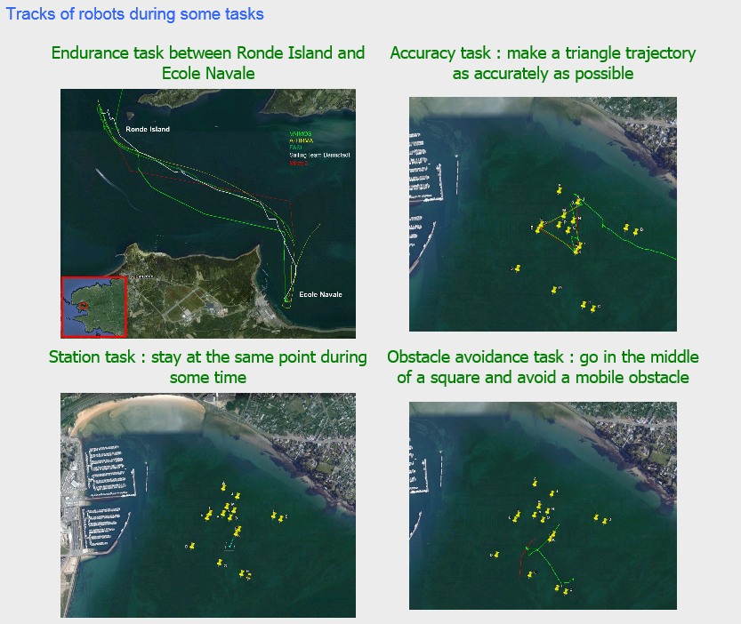

A high number of tasks was proposed in the hope that new types of problems would be tackled by some teams, while other existing problems could still be studied by other teams. It was foreseen that no team would be able to reasonably try all the tasks in the given time, therefore they implicitly had to make a selection.
7 teams with a total of 12 robots participated to the competition:
- A-TIRMA : student MS
- Aber Sailbot : student S
- Aberystwyth University: open M, (+2 spare open S)
- ENSTA Bretagne - Ifremer : open M (+spare open M), open S
- FASt : student MS, student S
- Handivoile Brest : open S
- Sailing Team Darmstadt : student MS
The following awards were given :
- Best open autonomous sailboat award : VAIMOS from ENSTA Bretagne - Ifremer team
- Best student autonomous sailboat award : FASt team
- Best autonomous microsailboat award : A-TIRMA team
- Best autonomous motorboat award : Aberystwyth University team
- Ecole Navale endurance special awards : VAIMOS, A-TIRMA, FASt
- Most professional student project award : Sailing Team Darmstadt
- Best open source architecture award : Aber Sailbot team
- Best mobile obstacle avoidance with an autonomous motorboat award : Motorboat from ENSTA Bretagne - Ifremer team
- Best innovation in control award : Handivoile Brest team
- ENSTA Bretagne – Ifremer team robots: VAIMOS autonomous sailboat and an autonomous motorboat built that year. VAIMOS was first at the endurance task and received the best sailboat in the open category award. The motorboat received a special prize for its success in the obstacle avoidance of known position task.
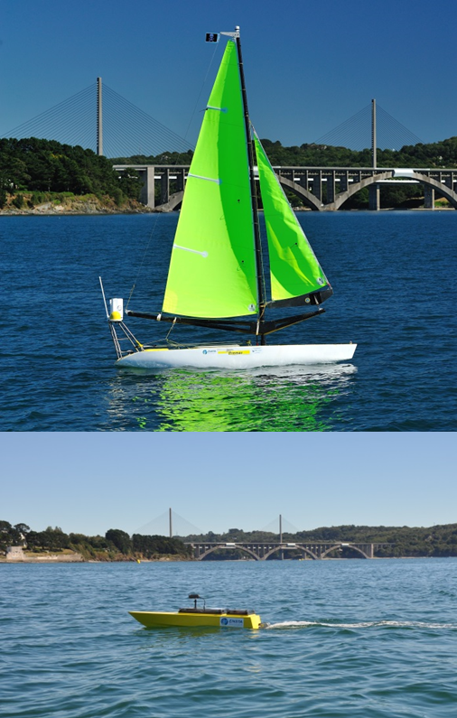
IRSC (International Robotic Sailing Conference) 2013 welcomed from the 2nd to the 3rd of September 2013 paper submissions on a wide range of topics around autonomous marine robotics (especially sailing robots), including but not limited to:
- Mechanical design and advanced materials
- Hardware and software organization
- Energy and power management
- Control architectures and algorithms
- Route planning and optimization
- Collision avoidance and boat to boat communication
- Machine learning and adaptation
- Applications of autonomous marine robots
- Legal issues for autonomous vessels
- Robotic boats in teaching
11 papers, involving authors from the teams and others, were published in the conference proceedings with Springer [7].
- Proceedings of IRSC 2013.
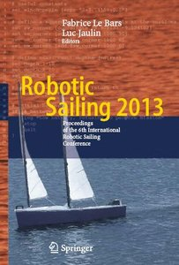

Specificities, issues and possible improvements
Organizing a competition such as the WRSC/IRSC 2013 required taking into account several elements.
Cost. Autonomous sailing robots are up to now less known than other types of drones, therefore it is harder to get money to work on them. As a result, the budget for the organization often requires the competitors and conference attendees to pay for a registration, and money awards cannot be given. However, this type of competition has made possible for sure to increase the interests of potential sponsors (e.g. HP was a funding partner of WRSC 2014, see [11]). In parallel, the costs for the teams are generally lower to prepare an autonomous sailboat rather than e.g. an AUV (Autonomous Underwater Vehicle). It is also mainly a student competition, the aim of that sort of competition is to make students discover autonomous robotics, and as most of the researchers work in universities, it is not difficult for them to find students for at least the competition. And this is also a good way for companies (the judges of the competition are often members from the industry) to get in touch with skilled and motivated students.
Variety of size, design and shapes, strong weather constraints make it difficult to setup rules. A small sailboat should be better e.g. for the station task than a big one, a big one should be better for endurance tasks, but if there is almost no wind, a big sailboat will not move at all while a small one would... It is hard to open the tasks to a very wide range of robots while keeping rules simple and easy to apply for judges, a harmonization formula is not enough/not easy to define to compare speeds of boats of different size whatever the wind conditions... To try to solve that, we made several categories and gave special prizes in addition to the place in a category.
Judge and give a score. Scoring is a hard problem for most autonomous robots competitions, especially in the marine environment. Contrary to underwater competitions such as SAUC-E (see [12], where you have other problems such as visibility, localization, etc.), in the air there is always a risk of manual communication. Additionally, manual safety control is required in certain circumstances to be able to prevent collisions or avoid losing the robots outside the competition area. For that, several judges must be available to monitor the teams and the robots, and tasks must be defined so that a robotic system would likely be better than a human controlled one (in terms of accuracy, repetitiveness, etc.). To limit subjective interpretations, we attempted to define rules and scoring so that an automatic script would be able to compute scores with robots log files as inputs. Therefore, a tracking system was developed from Android smartphones to log GPS data, angles and inertial data, and send them in real time via SMS/3G (see 2013 version on [1] and latest on [13]). Thanks to this system, the track of some robots could be followed in real-time onshore.
Collisions and sharing the area. Some tasks such as the endurance task required to have all the robots competing autonomously together on a long distance. To handle that safely, a chase boat was provided for almost each robot. Additionally, all the robots are limited to 4 m long and 500 kg so that a small human-controlled motorboat can tow them if needed. It is also worth to note that even under manual remote control, it can be difficult to manoeuver a sailing robot in all conditions.
Some possible improvements have been identified after the event. Since teams often need to make tests at sea in the same time, it is important to have enough judges and chase boat pilots, with distinctive signs so that teams can identify them (tee-shirt, cap), and indicate their availability on a public schedule. We should try to assign a dedicated chase boat, a driver, a judge to each team and provide also as far as possible a GPS tracker (such as a smartphone able to log and send GPS, angles, speeds, accelerations) and a waterproof camera (e.g. GoPro) to ensure we get the most of data from the robots at sea. Additionally, more boats with electricity onboard (only 2 were available in 2013, in addition to the semi-rigid boats) would help teams a lot. Aside from the competition organization itself, it would be valuable to have someone dedicated to talk with journalists, take pictures and videos of the robots as well as put the conference presentations on YouTube, update websites and Facebook pages everyday to ensure a maximum media coverage of the event.

Conclusion
The World Robotic Sailing Championship (WRSC) is intended to promote the development of autonomous wind propelled sailing robots, through a series of short distance races, navigation and autonomy challenges while the accompanying International Robotic Sailing Conference (IRSC) provides researchers working on problems related to autonomous marine robotics the chance to exchange ideas with a scientific conference. The WRSC/IRSC 2013, organized in Brest, France from the 2nd to the 3rd of September 2013 was the 6th edition of the event and once again managed to gather several teams, mainly from Europe, to share their latest developments in autonomous marine robotics. The 2014 event was in Galway, Ireland and the 2015 edition should take place in Aland Islands, Finland.

References

- http://www.ensta-bretagne.eu/wrsc13/
- http://www.roboticssailing.org/
- L. Jaulin. “Modélisation et commande d’un bateau à voile”, in CIFA2004 (Conférence Internationale Francophone d’Automatique), In CDROM, Douz (Tunisie), 2004.
- C. Sauze and M. Neal. “An autonomous sailing robot for ocean observation”, in proceedings of TAROS 2006, pages 190–197, Guildford, UK, 2006.
- G.H. Elkaim and R. Kelbley. “Station Keeping and Segmented Trajectory Control of a Wind-Propelled Autonomous Catamaran”, in Proceedings of the 45th IEEE Conference on Decision and Control, San Diego, USA, 2006.
- Y. Brière. “The first Microtransat challenge”, http://web.ensica.fr/microtransat/ . ENSICA, 2006.
- F. Le Bars and L. Jaulin. Robotic Sailing 2013. Proceedings of the 6th International Robotic Sailing Conference, 2013.
- F. Le Bars and L. Jaulin. “An experimental validation of a robust controller with the VAIMOS autonomous sailboat”, in proceedings of the 5th International Robotic Sailing Conference, Cardiff, England, 2012.
- L. Jaulin and F. Le Bars. “An interval approach for stability analysis; Application to sailboat robotics”, IEEE Transaction on Robotics, Volume 27, Issue 5, 2012.
- http://www.marinetraffic.com/
- http://wrsc2014.com/
- http://www.sauc-europe.org/
- http://haggis.ensta-bretagne.fr:3000/

