SARDINE : a low-cost AUV for detection, localization, tracking and mapping of underwater targets

F. Le Bars*, A. Manzanilla Magallanes**, M. A. Garcia Rangel**
*ENSTA Bretagne, Lab-STICC/CID/PRASYS, STIC/OSM
**UMI LAFMIA, CINVESTAV-IPN Mexico

Keywords: AUV (Autonomous Underwater Vehicle), localization, interval arithmetic, control, mapping.

For a large number of applications, there is an increasing need of low-cost underwater robots able to do automatically and repetitively specific tasks. Examples of such tasks are:
- Detect and localize objects such as acoustic beacons put to mark a place, plane black boxes, etc.
- Follow pipelines automatically and regularly to detect e.g. leaks.
- Clean or inspect boat hulls or specific areas in a harbor.
- Generate a video mosaic of the sea floor to characterize it, e.g. the type of sea weeds.
For now, some of these tasks are done by:
- Divers: depending on the task, the cost and time to deploy them might be high or they might be put at risk.
- ROVs (Remotely Operated Vehicles): they need a boat to be operated, and their cable might cause problems in some situations (entanglement).
- AUVs (Autonomous Underwater Vehicles): for the moment, the ones available on the market are often big and expensive, and the data of their numerous and expensive embedded sensors are often not used enough. Additionally, any failure on such kind of robot often cancels the task.
For these reasons, cheaper autonomous underwater robots need to be designed and new algorithms need to be developed on them. This is the purpose of SARDINE.
SARDINE is a low-cost AUV based on an aluminum tube with 3 thrusters. It has a pressure sensor to know its depth, a mid/low-cost AHRS (Attitude and Heading Reference System), 2 cameras (e.g. put in bottom+front), low-cost rotating sonar, low-cost acoustic modem and an embedded computer with Wi-Fi and GPS (only in surface). In particular, it does not have a DVL to measure its speed nor an echosounder to measure its altitude (altitude can be inferred from bottom camera and sonar with a little bit of data processing). Especially because of the lack of DVL, intelligent methods need to be developed to still be able to do the missions. And thanks to its acoustic modem with ranging capabilities, it has the possibility to cooperate with other vehicles such as an ASV (Autonomous Surface Vehicle) to improve its position estimation or parallelize the mission tasks.

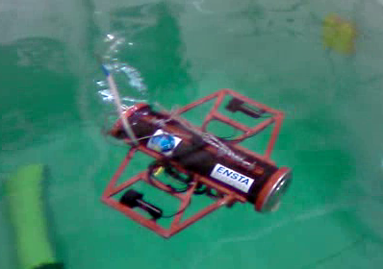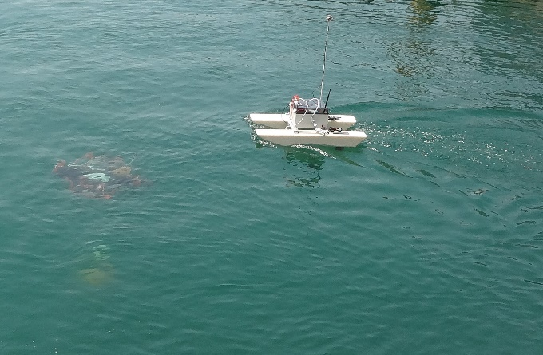
SARDINE, alone (left) and cooperating with an ASV (right).

To try to overcome all its hardware limitations, the main particularity of SARDINE is that its fusion algorithms for localization use interval arithmetic to handle in a simple way the uncertainties from its low-cost sensors as well as the strong non-linearities of underwater robotics. This is especially useful to make a localization algorithm able to deal with the large number of outliers in sonar data when trying to localize in a known structured environment.

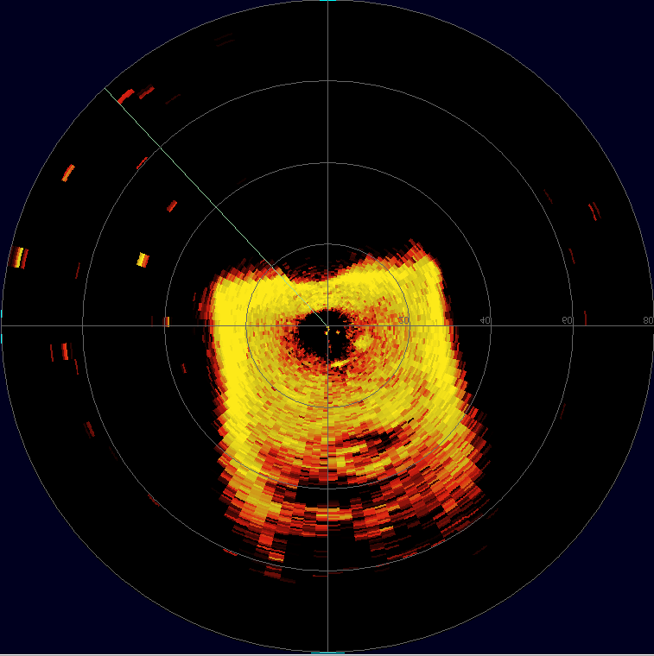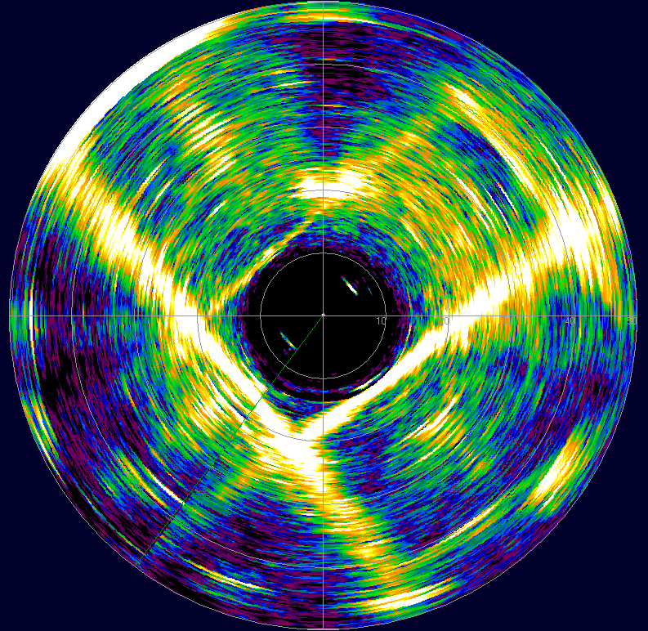
Sonar data in 2 different pools. Different types of outliers are visible depending on the situation.

In this presentation, we will try to describe the main design and algorithms particularities of SARDINE and illustrate their applicability to the SAUC-E 2016 competition, where SARDINE got the 1st prize.

